SOUTH COAST BAJA RIDE
MAKE PLANS NOW. Join your friends for a unique weekend.
GREAT FOOD, LIVELY MUSIC, BEAUTIFUL RIDING, UNFORGETTABLE MEMORIES!

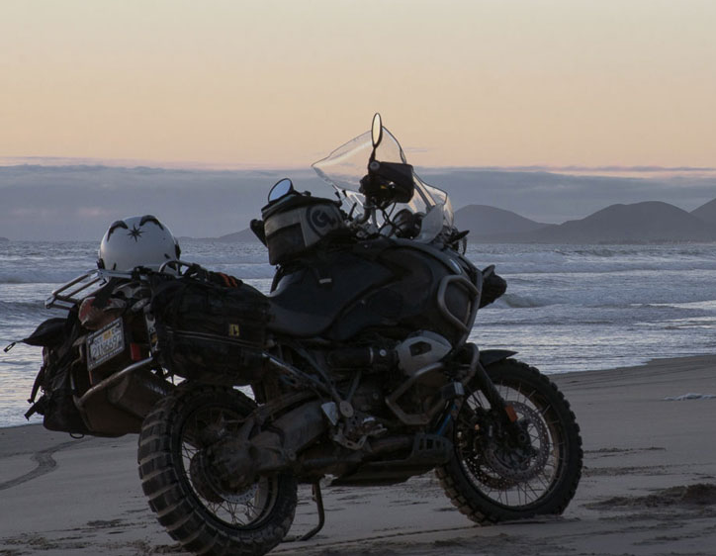
The 3-day trip—April 24-26—leaves from Irv Seaver on Friday, covering about 320 miles traveling south through Tijuana and Ensenada, then east to San Felipe on the Sea of Cortez where we will stay in a hotel Friday and Saturday nights. Street and off road day-rides are planned for Saturday. We’ll return on Sunday to the good ole’ USA via the crossing at Tecate.
Who, What, When, Where, Why
Route
Day 1: Irv Seaver south to border crossing at Tijuana, south to Ensenada for lunch, east to San Felipe. Hotel in San Felipe
Day 2: Day trip, street ride south on Hwy 5 to Coco’s Corner. GS’s day ride to Mike’s Sky Ranch. Hotel in San Felipe
Day 3: North toward Mexicali, west on Hwy 2D to border crossing at Tecate, north to release point, TBD.

$$$
Food and Fuel: $80-$100
Hotel: $100 per night
Insurance: based on the value of your motorcycle

Border Crossing
Passport: you WILL NEED one. https://travel.state.gov/content/travel/en/passports.html/.
Currency exchange: We will stop at the border to exchange dollars for pesos.

